Challenge 01 – Smart City Temperature Alerts
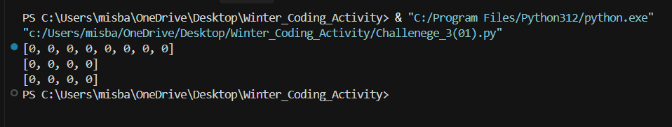

Challenge 02 – Emergency Evacuation Boats
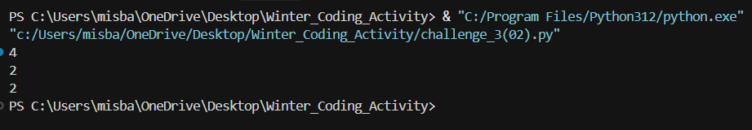

Challenge 03 – Broadcast Network Feed
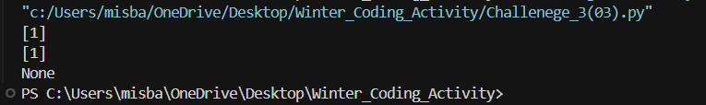

Challenge 04 – Scrambled Keyword Detection
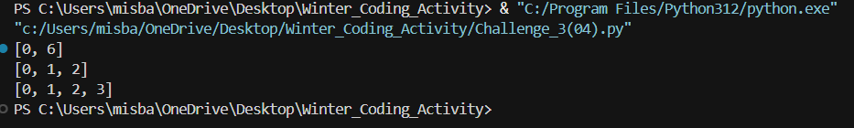

Challenge 05 – Longest Mirrored Phrase
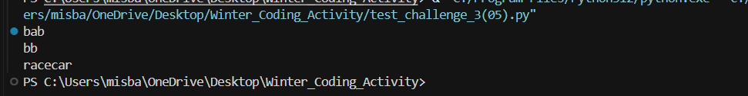

Challenge 06 – Suspicious Device Detection
